# Congestion Control

# NAME: Ayush Sharma

# REG NO: 15BCE1335

**Changing Throughput value**

Ax=[500 465 450 465 500 535 550 535];

Ay=[100 150 200 250 300 250 200 150];

Bx=[400 300 200 250 300 350 400];

By=[100 100 150 175 200 200 200];

Cx=[600 700 800 750 700 650 600];

Cy=[100 100 150 175 200 200 200];

Dx=[175 175 200 225 275 300];

Dy=[225 300 350 400 375 300];

Ex=[350 375 415 450];

Ey=[300 350 400 350];

Fx=[550 600 650 650];

Fy=[350 400 350 300];

Gx=[700 725 750 775 800];

Gy=[300 350 400 350 300];

Hx=[250 275 325 375 400];

Hy=[500 550 600 550 500];

Ix=[650 675 715 750 750];

Iy=[450 550 600 550 450];

Jx=[550 550 575 625 675];

Jy=[450 550 650 700 650];

Kx=[350 400 450 515 575];

Ky=[700 750 800 800 750];

nodx=[Ax Bx Cx Dx Ex Fx Gx Hx Ix Jx Kx]; nody=[Ay By Cy Dy Ey Fy Gy Hy Iy Jy Ky]; heA=[1 2 3 4 5 6 7 8];

taA=[2 3 5 6 6 7 8 1];

heB=[1 9 10 11 12 13 14 15];

taB=[9 10 11 12 13 14 15 3];

heC=[1 16 17 18 19 20 21 22];

taC=[16 17 18 20 20 21 22 7];

heD=[10 23 24 25 26 27 28];

taD=[23 24 25 26 27 28 13];

heE=[14 29 30 31 32];

taE=[29 30 29 32 4];

heF=[6 33 34 35 36];

taF=[33 34 35 36 21];

heG=[20 37 38 39 40 41];

taG=[37 38 39 40 41 18];

heH=[26 42 43 44 45 46];

taH=[40 43 44 45 46 31];

heI=[35 47 48 49 50 51];

taI=[47 48 49 50 51 39];

heJ=[33 52 53 54 55 56 34];

taJ=[52 53 54 55 56 49 47];

heK=[44 57 58 59 60 61 45];

taK=[57 58 59 60 61 55 53];

he=[heA heB heC heD heE heF heG heH heI heJ heK]; ta=[taA taB taC taD taE taF taG taH taI taJ taK]; n=length(nodx);

[gt] = NL_G_MakeGraph('ARC',n,ta,he,nodx,nody); f=NL_G_ShowGraphN(gt,1); marc=zeros(11,30);//11 arcs

marc(1,1:length(heA)+1)=[heA taA($)];marc(1,$)=length(heA)+1; marc(2,1:length(heB)+1)=[heB taB($)];marc(2,$)=length(heB)+1; marc(3,1:length(heC)+1)=[heC taC($)];marc(3,$)=length(heC)+1; marc(4,1:length(heD)+1)=[heD taD($)];marc(4,$)=length(heD)+1; marc(5,1:length(heE)+1)=[heE taE($)];marc(5,$)=length(heE)+1; marc(6,1:length(heF)+1)=[heF taF($)];marc(6,$)=length(heF)+1; marc(7,1:length(heG)+1)=[heG taG($)];marc(7,$)=length(heG)+1; marc(8,1:length(heH)+1)=[heH taH($)];marc(8,$)=length(heH)+1; marc(9,1:length(heI)+1)=[heI taI($)];marc(9,$)=length(heI)+1; marc(10,1:length(heJ)+1)=[heJ taJ($)];marc(10,$)=length(heJ)+1; marc(11,1:length(heK)+1)=[heK taK($)];marc(11,$)=length(heK)+1; [cmarc]=NL_R_ARCCursor(marc); [RTARC]=NL_R_ARCRT(cmarc);

s=1;

[RTARCO]=NL_R_ARCRTInit(RTARC,s);//initial routing table A=[cmarc(:,1:$-1) zeros(lc,2) cmarc(:,$)];

[lc cc]=size(cmarc);

A=[cmarc(:,1:$-1) zeros(lc,2) cmarc(:,$)]; for i=1:lc

curs=A(i,$-3); direct=RTARCO(curs,3); if (direct==1) then

A(i,$-2)=1;//left A(i,$-1)=0;//right

else

A(i,$-2)=0;//left A(i,$-1)=1;//right

end end

s1=30;//first source [L1]=NL_R_ARCTrafficNode(A,s1,gt); s2=35;//second source [L2]=NL_R_ARCTrafficNode(A,s2,gt); t1=25;

t2=0;

T=t1*L1+t2*L2;//total traffic Tmax=50;//maximum throughput dmax=10;//border display Tcong=Tmax/2;

t1=Tcong+1;

T=t1*L1+t2*L2;//total traffic [go]=NL_R_ARCTrafficPlot(A,T,Tmax,dmax,gt,2);//application of NL_R_ARCTrafficPlot [congarc,dircongarc]=NL_R_ARCCongestionDetect(T,Tcong,A,gt)//application of NL_R_ARCCongestionDetect

for j=1:length(congarc) [A]=NL_R_ARCCongestionLR(A,congarc(j),0.1,dircongarc(j),1); end

A

# T=100

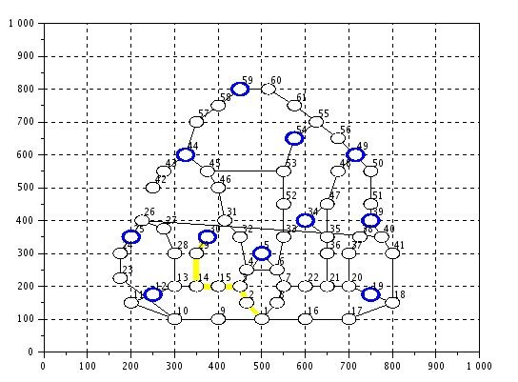

**OUTPUT**

-->mean(T) ans =

4.890411

-->Tcong Tcong =

50.

# T=50

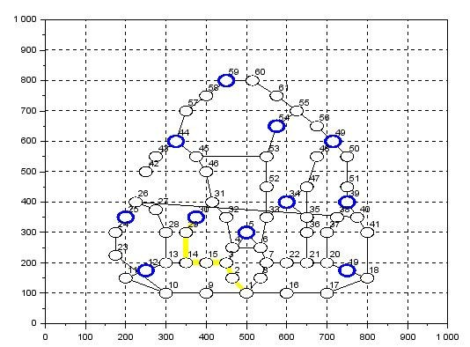

**OUTPUT**

-->mean(T) ans =

2.4931507

-->Tcong Tcong =

25.

# T=5

**OUTPUT**

-->mean(T) ans =

0.3356164

-->Tcong Tcong =

2.5

# T=1

**OUTPUT**

-->mean(T) ans =

0.1438356

-->Tcong Tcong =

0.5

# INFERENCE

-->x=[4.890,2.49,0.33,0.14]

x =

4.89 2.49 0.33 0.14

-->plot(x)

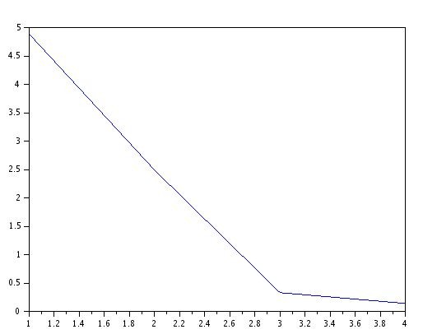

# Traffic values on different Tmax values